Buy Box Check Automation
Task Brief for the Automation Team | PH Dashboard

1. Objective
Manually checks whether we have the Buy Box. If we do not have it, we then dig around to find out why. This takes a lot of time.
Goal: Build an automation that does this check for every ASIN, tells us Yes or No for Buy Box, and, when it is No, tells us the most likely reason. The result should be shown on a dashboard screen.

2. Current Manual Process
- Open the PH Dashboard.
- Pick an ASIN from the list.
- Check if our offer is the Buy Box for that ASIN.
- If YES: mark as Buy Box Won. Nothing more to do.
- If NO: investigate the reason (price, stock, listing status, seller account, etc.).
- Write the reason in a sheet.
- Repeat for the next ASIN.

3. What We Want to Automate
- Read the list of ASINs from the PH Dashboard automatically.
- For each ASIN, check if we are the Buy Box winner (Yes / No).
- If No, run a checklist and pick the most likely reason .
- Save the result with date and time, so we can see history.
- Show everything on a simple dashboard screen with filters.
- Run on a schedule and also on demand with a Run Check button.

4. Input and Output

Input
Field | Description
ASIN | Product ID taken from the PH Dashboard (single or full list)
Seller / Account | Our seller account used for comparison
Marketplace | Amazon

Output (per ASIN)
Field | Description
Buy Box Status | YES or NO
Reason | Main reason if status is NO
Stock | Our available quantity
Listing Status | Active, Inactive or Suppressed
Last Checked | Date and time of the check

5. Automation Logic (Simple Flow)
- Take the ASIN.
- Check Buy Box owner. If it is us, set Status = YES and stop.
- If not us, set Status = NO and go to the reason checks.
- Run checks 1 to 8 from Section 5 in order. Stop at the first match and save it as the Reason.
- If nothing matches, save Reason = Unknown.
- Save the result with date and time, and refresh the dashboard.

6. Dashboard UI
Below is a sample screen of how the dashboard should look. Numbers and names are only examples.
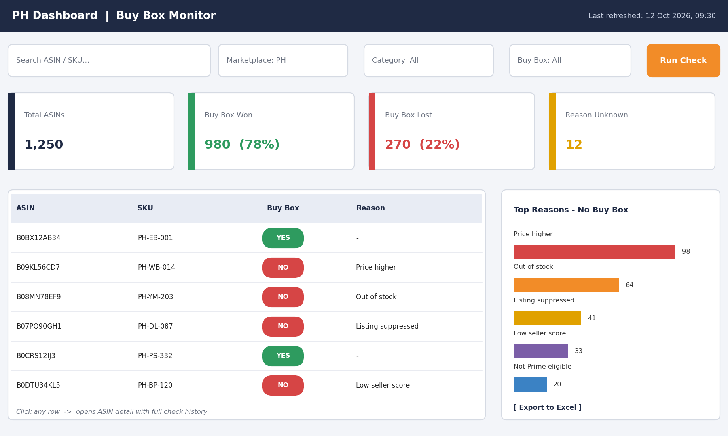

Colour rules
- Green: Buy Box YES
- Red: Buy Box NO

8. Schedule and Alerts
- Run automatically once a day.
- Run on demand using the Run Check button.
- Send an alert when a high-priority ASIN loses the Buy Box.

9. Done Criteria
- All ASINs in the PH Dashboard are checked without manual work.
- Every NO result has a reason, or is marked Unknown.
- Results match a manual spot check on a sample of ASINs.
- Dashboard shows filters, summary cards, table, reasons chart and Excel export.
- History of daily results is stored.

10. Questions for the Team to Confirm
- Which data source gives Buy Box and listing details (API, report, or dashboard data)?
- How many ASINs per run, and how long should a full run take?
- What time should the daily run happen?
- Who should receive alerts?
- Is any reason missing from?

